**OUTPUTS**

**EXERCISE-1**

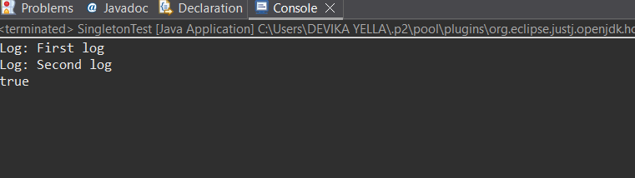

**EXERCISE-2**

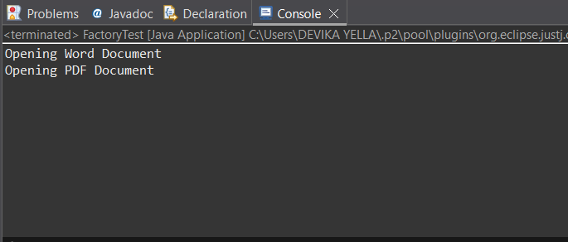

**EXERCISE-3**

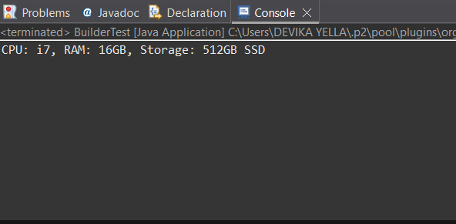

**EXERCISE-4**

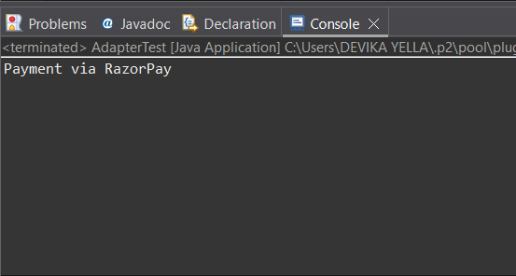

**EXERCISE-5**

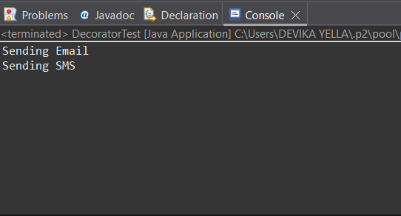

**EXERCISE-6**

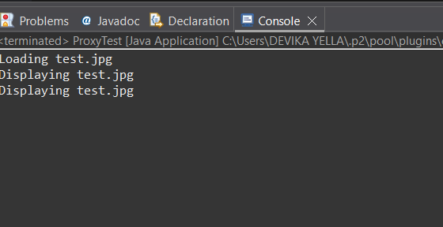

**EXERCISE-7**

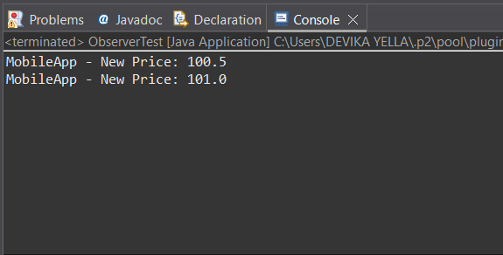

**EXERCISE-8**

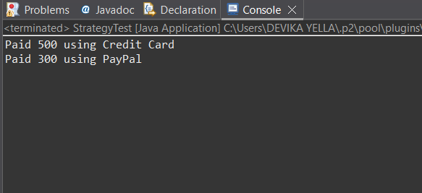

**EXERCISE-9**

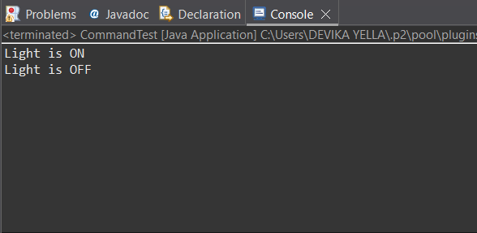

**EXERCISE-10**

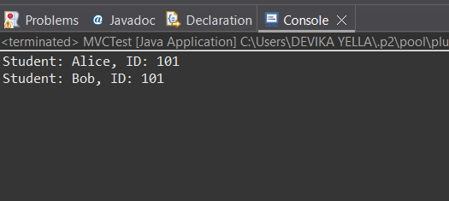

**EXERCISE-11**

